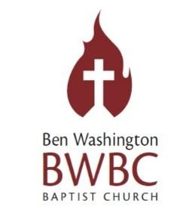

3901 Frisco Ave
Irving, Tx 75061
972-790-8421

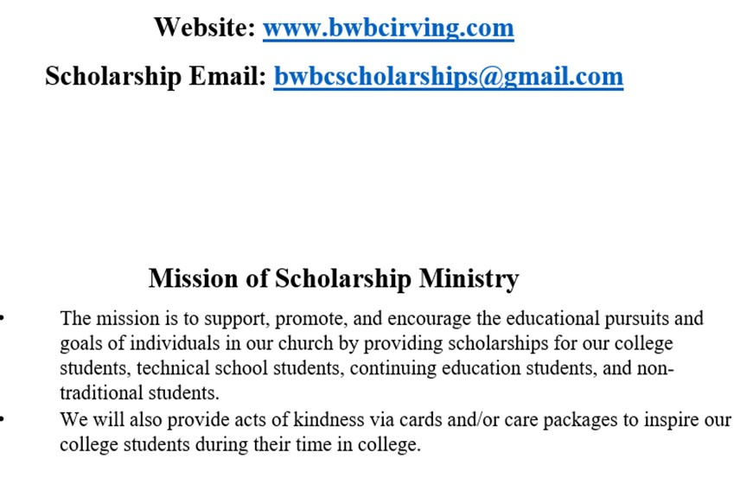

Grow, Glow Go!!!

3901 Frisco Avenue ● Irving, TX 75061
- Office: (972) 790-8421 ● FAX: (972) 986-6590
- EMAIL: bwbcscholarships@gmail.com ● Website: www.bwbcirving.com

BWBC SCHOLARSHIP APPLICATION

Student Information:

Applicant’s Full Name: _______________________________________________
Last First Middle Initial

Applicant’s Complete Address:

____________________________________________________________
STREET ADDRESS

____________________________________________________________
CITY STATE/PROVINCE POSTAL CODE/ZIP CODE

____________________________________________________________
Phone E-mail Address

Family Information:

Father’s
Name:____________________________________________________________

Mother’s
Name:____________________________________________________________

Education Information:

Date of high school graduation: ________________________________________

Date to enter (or entered) college: ______________________________________

Name of college attending: ___________________________________________

College Major or Career Interest: ______________________________________

Church/Community/School Involvement:

List interests, activities & achievements:

Church:
____________________________________________________________
____________________________________________________________
____________________________________________________________

Community:
___________________________________________________________
___________________________________________________________
___________________________________________________________

School:
___________________________________________________________
___________________________________________________________
___________________________________________________________

Check the scholarship(s) you are applying for (you may choose more than one): _____ Dr. J.R. Sheppard Scholarship (High School Graduates Only)
_____ Earlie Wheeler Oratorical Scholarship (High School Graduates Only) _____ Collegiate Oratorical Scholarship (College Students Only)

Signed and submitted the attached "Assignment of Rights & Consent to Publish Scholarship Information": Yes / No

Submit completed application and required documents in the enclosed envelope to BWBC Church Administrator. The deadline to submit your application and required documents is May 20, 2021 by 12 a.m. (midnight). No applications will
be accepted after this date.

If you have questions, please contact Sherrie Sutton, Scholarship Committee Chairperson at 817-658-7163, bwbcscholarships@gmail.com.

___________________________________________Date________________ Applicant’s Signature

RIGHTS & CONSENT TO PUBLISH SCHOLARSHIP INFORMATION

ASSIGNMENT OF RIGHTS & CONSENT TO PUBLISH
SCHOLARSHIP INFORMATION

KNOW ALL PERSONS BY THESE PRESENTS:

THAT I, ______________________________________________________, do hereby give Ben Washington Baptist Church full rights to publish my name, my pertinent family information, college I am attending, photographs that I have provided, and college update information.

I understand that by execution of this agreement, I am relinquishing my rights to any compensation for reproduction, publication or use of the above information by Ben Washington Baptist Church in its print or electronic correspondence, catalog, or on its website.

I hereby specifically waive my right to review or approve THE MODIFICATION of the above Information. (Modifications may be made to accommodate size or content restrictions. Modifications will not be made to “distort” or “falsify” any information provided.)

I understand that this Agreement in no way obligates Ben Washington Baptist Church to publish or use the above-described information.

EXECUTED this date of ____________________________.

By: ________________________________________
(Print Name)

________________________________________
(Signature)

DR. J.R. SHEPPARD SCHOLARSHIP
Dr. Joseph R. Sheppard Scholarship was established in honor of the 2nd Pastor of Ben Washington Baptist Church. Pastor Sheppard served 51 ½ years as spiritual leader, teacher, counselor, and friend to many. As one who valued education as a pivotal endeavor, it was his esteem pleasure to endorse this scholarship to assist high school students in pursuing higher education.

Scholarship Amount: $2000 will be divided equally between the high school graduates.
If there is only one (1) applicant, they applicant will receive $1000 for the year with
the same qualifications as stated below.
Qualifications:
- Must be an active member of Ben Washington Baptist Church
- Must be a high school graduate

Required Documents to be submitted to Scholarship Ministry.
- Completed J.R. Sheppard Scholarship Application
- High School Transcript
- Proof of admission/enrollment to 2-year college / 4-year university along with financial aid office phone number and address (show proof by September 15, 2021)
- Proof of minimum 2.5 Cumulative GPA (due by January 19, 2022)
- Proof of Spring Semester Enrollment (due by January 19, 2022)
- Students must write a 600-word essay using Times Roman size 12 font Topic: “How did you use your faith to persevere through the coronavirus pandemic?”
- Letter of Recommendation from one (1) member of BWBC and one (1) from schoolteacher, principal, school counselor

AWARDS:
- Dr. J.R. Sheppard Scholarship will be divided between qualified applicants. The first half of the funds will be dispersed before or by October 1, 2021. The second half will be dispersed by February 16, 2022. Checks will be made payable to the college/university only and will be forwarded to the Business Office.

APPLICATION DUE DATE: May 20, 2021

PRESENTATION DATE: May 23, 2021
***Submit pre-recorded video with a solid background. Wear your gown to represent your school. Submit the video to bwbcscholarships@gmail.com

EARLIE MAE WHEELER ORATORICAL ESSAY SCHOLARSHIP

Mrs. Earlie Mae Wheeler was one of Irving’s first African American school teacher and a devoted member of Ben Washington Baptist Church. She taught her students to excel in reading, writing, and arithmetic, to think creatively, and to hold steadfast to their morals and principles. A tribute to Mrs. Wheeler’s commitment to educating Irving’s students is the Wheeler Transition Center and her picture at Irving High School.

Scholarship Amounts:
1st ---------------------$600
2nd -------------------- $400
3rd -------------------- $250

QUALIFICATIONS:
- Must be an active member of BWBC and involved in at least one ministry and/or attend service regularly.
- High School Graduate
- Must provide proof of enrollment to college/university for the 2021-2022 school year with a minimum of 12 semester hours (show proof by September 15, 2021)

ESSAY / ORATORICAL GUIDELINES:
- Title page with name, high school, and date for judge’s copy of essay
- 600-word typed, double-spaced essay, using Times New Roman, Font size 12
- Presentation of speech no longer than five minutes
- Business Attire

ESSAY AND ORATORICAL JUDGING CRITERIA (Rubric with weight of each category will be provided in application packet)
- Persuasiveness of message
- Sentence structure and grammar
- Neatness of the document
- Creativity
- Body Language
- Articulation
- Familiarity with Essay
APPLICATION / ESSAY DUE DATE: May 20, 2021
PRESENTATION DATE: High School Recognition Day During Both Worship Services

BWBC COLLEGIATE ORATORICAL ESSAY SCHOLARSHIP

The BWBC Collegiate Oratorical Essay Scholarship, originally the Earlie Mae Wheeler Scholarship for college students is available for undergraduate college students.

Scholarship Amounts:
1st ------------------ $350
2nd ------------------$250
3rd ---------------------------- $200
QUALIFICATIONS:
- Must be a college student and an active member of BWBC
- Cumulative 2.5 GPA
- Must provide proof of enrollment to college/university for the 2020-2021 school year with a minimum of 12 semester hours (show proof by September 15, 2021)

ESSAY / ORATORICAL GUIDELINES:
- Title page with name, college, and date for judge’s copy of essay
- 600-word typed, double-spaced essay, using Times New Roman, Font size 12
- Presentation of speech no longer than five minutes
- Business Attire

ESSAY AND ORATORICAL JUDGING CRITERIA (Rubric with weight of each category will be provided in application packet)
- Persuasiveness of message
- Sentence structure and grammar
- Neatness of the document
- Creativity
- Body Language
- Articulation
- Familiarity with Essay (no verbatim reading): You may use note cards day of presentation
APPLICATION / ESSAY DUE DATE: May 20, 2021
PRESENTATION DATE: High School Recognition Day During Both Worship Services

ESSAY TOPICS FOR EARLIE MAE WHEELER ORATORICAL

& COLLEGIATE ORATORICAL

Submit an essay of 500 words on ONE of the following topics (all essays must include at least 5 references from the scriptures)

Topic I: How to live as a Christian by God’s word and be a Millennial (Romans 12:2)

Topic II: What challenge(s) you’ve overcome that you feel has/have strengthen your faith and have made you better because of it/them (Philippians 4:13)?

Topic III: Describe a change you would like to make in the world and why
(Ecclesiastes 3:1). Elaborate on any obstacles you might encounter along the way.

Topic IV: Explain how helping others has shaped your perspective on humanity (Hebrews 13:16). Elaborate on how these experiences influence your future ambitions and career choice.

